Importing PowerPoint into MovieMaker
Create PowerPoint
Save As--Other Formats
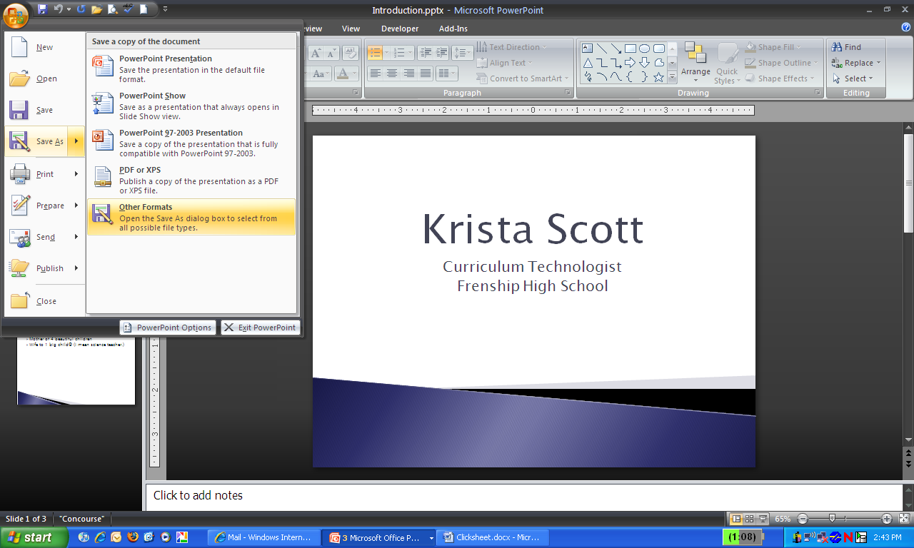
Select JPEG File Interchange Format
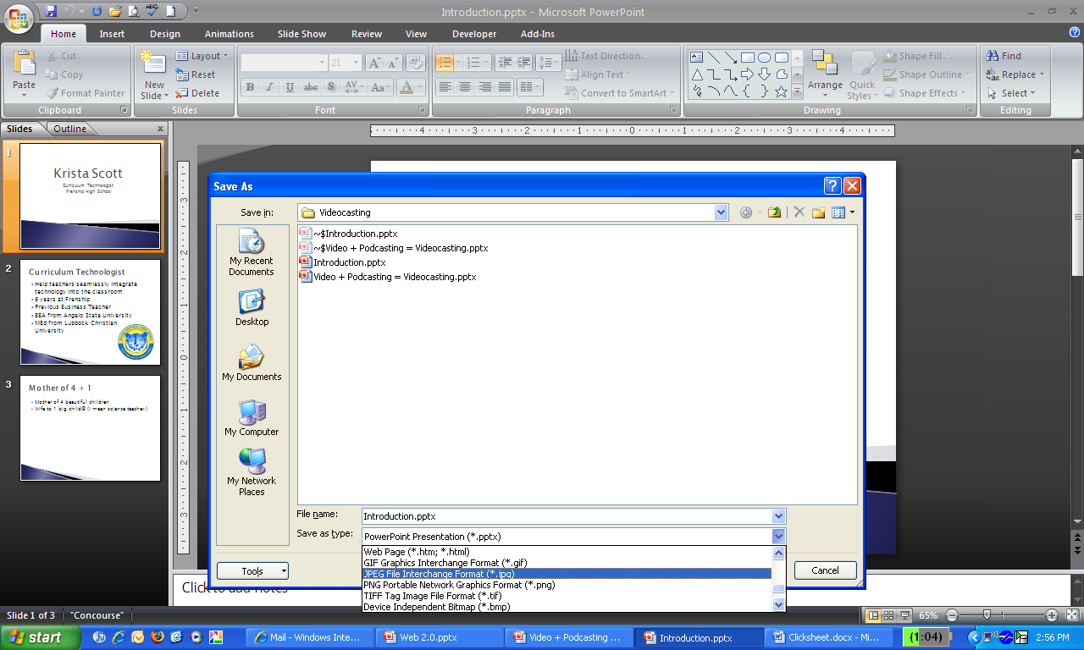

Select Every Slide
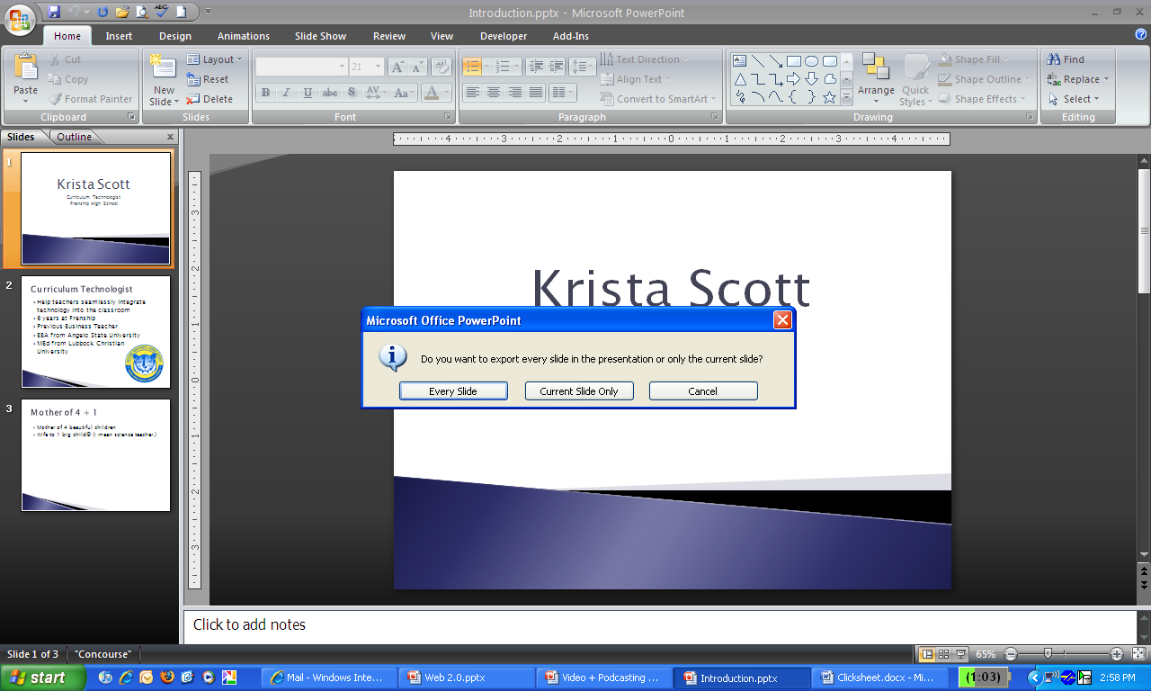
Open Windows Movie Maker
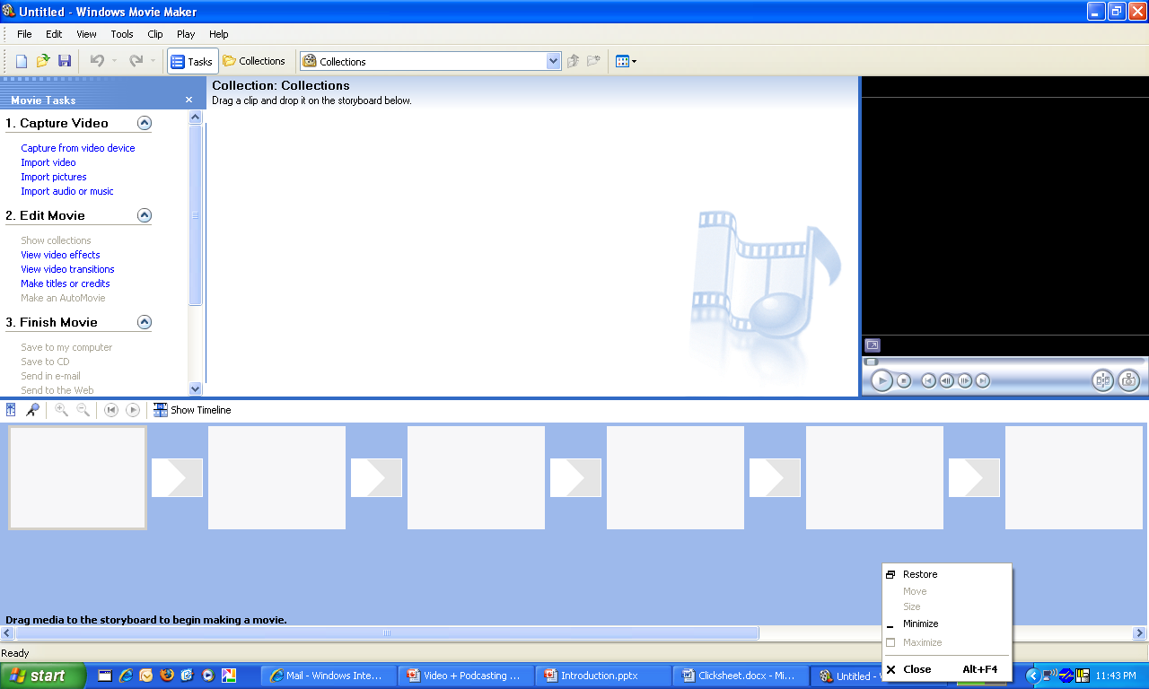
Click Import Pictures and locate saved pictures (PowerPoint slides)
Click on the Microphone icon
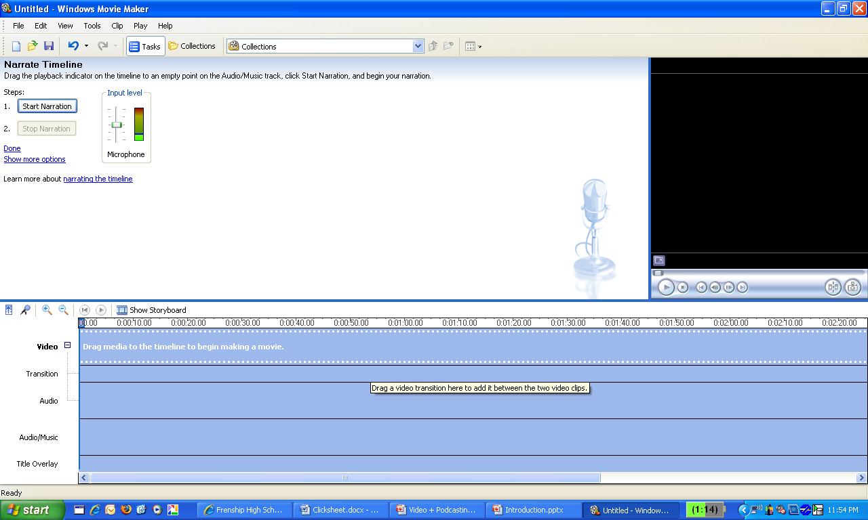
Record Sound
Drag down pictures and/or video clips and match up with music
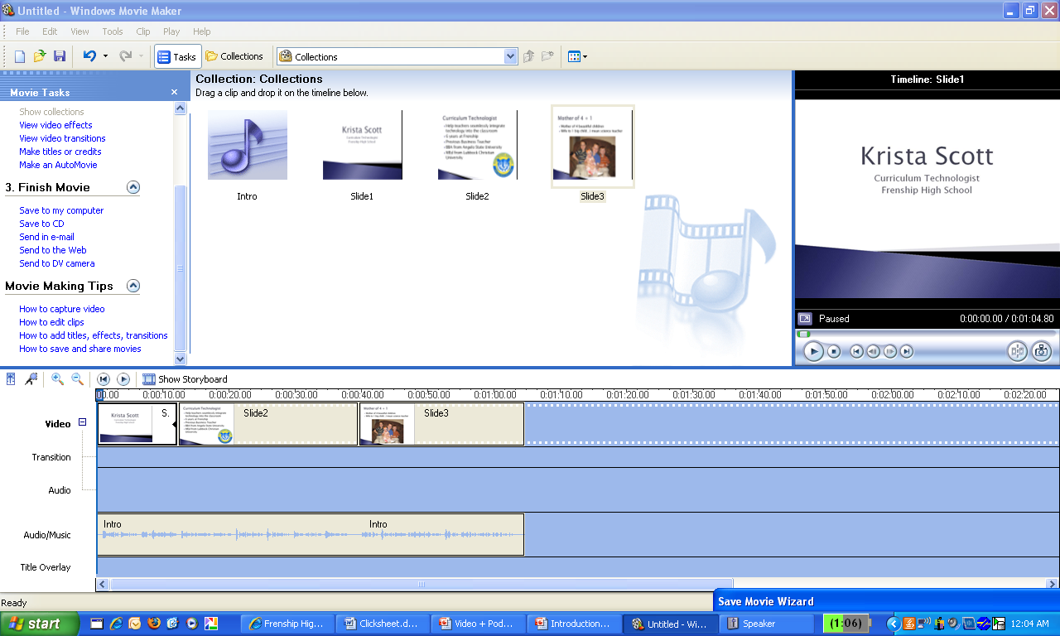
Click Save to My Computer and follow the steps
Congratulations! You are done!!!

